**Mongolia through Historical Photographs**

**Монгол түүхэн гэрэл зурагт**

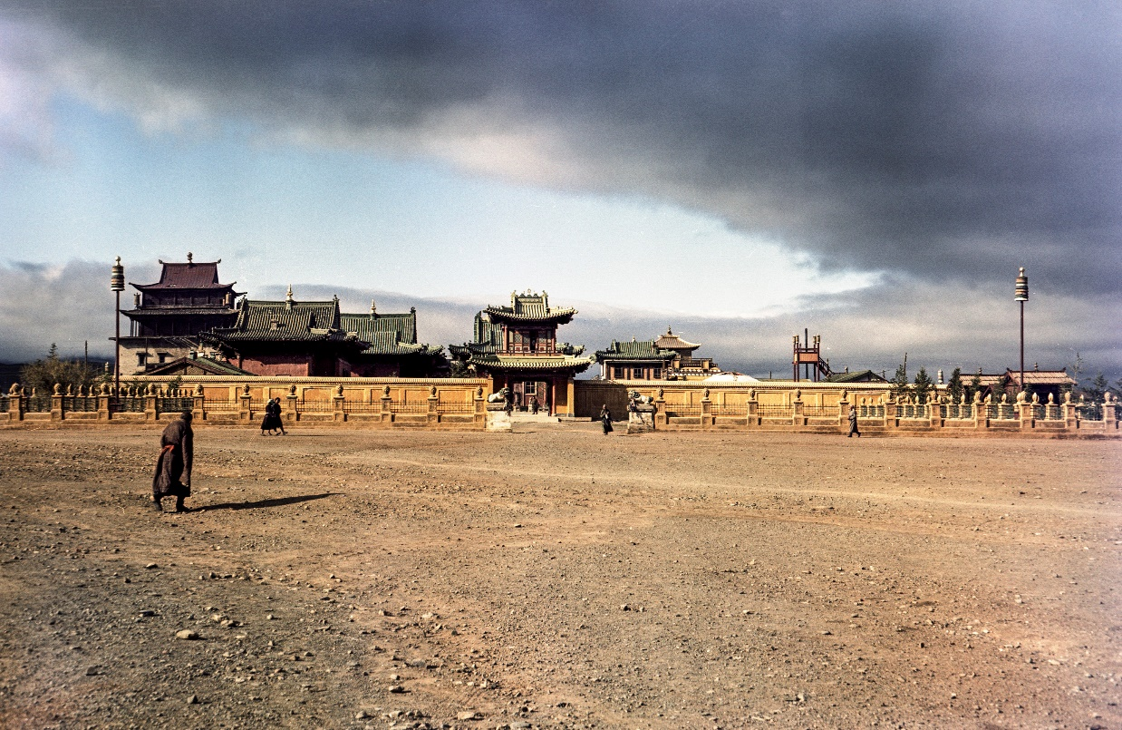

Dear colleagues,

We would like to invite you to the international conference “Mongolia through Historical Photographs” that will be held in Prague, Czech Republic, from **April 25 to 26, 2024**. This conference is organized by the Department of Mongolian Studies of the Institute of Asian Studies (Faculty of Arts, Charles University) in cooperation with Department for the Study of Religions (Faculty of Arts, Masaryk University) and the National Museum of Czech Republic with intention to create a forum for exchange of information, knowledge and experiences in the field of collection, preservation and research of the historical photographs related to Mongolia.

The topics that are expected to be discussed at the conference include, but are not limited to:

* The Mongolia-related photographs in the institutional and private collections;
* Attaching data to the Mongolia-related historical photographs;
* Mongolia-related photographs as a source of research;

 ***

The conference will be held in hybrid format, although in-person attendance is highly preferred.

There is no **conference fee.** The participants are responsible for covering their travel expenses, accommodation and meals.

**LANGUAGE OF THE CONFERENCE**

The main language of the conference is English. If you prefer Mongolian, please contact the organizers for further arrangements for your comfort.

**TIME OF THE PRESENTATION**

At the conference, each presenter will be given 20 minutes for the presentation. Each section will be concluded by a 20-minute follow-up discussion.

**REGISTRATION FOR THE CONFERENCE**

We kindly ask you to fill the form below and send it to the organizers ([uvs@seznam.cz](mailto:uvs@seznam.cz) or [belka@phil.muni.cz](mailto:belka@phil.muni.cz)) together with the short abstract (250 words maximum).

**On behalf of the Organizing Committee:**

Veronika Kapišovská

Department of Mongolian Studies

Institute of Asia Studies, Faculty of Arts, Charles University